Lab Report

Your Information
Your Name: Joshua Zimmerman-Gibson
Assignment Title: Build a Storyboard in Tableau

Screenshots
- Open the workbook you created in the Performance Assessment: Create Visualizations in Tableau.
- Update the Bar Chart. Add the Count of products as a color mark. Change the coloring to Green-Gold. Add Aisle as a filter and limit the results to the top 10 product counts.
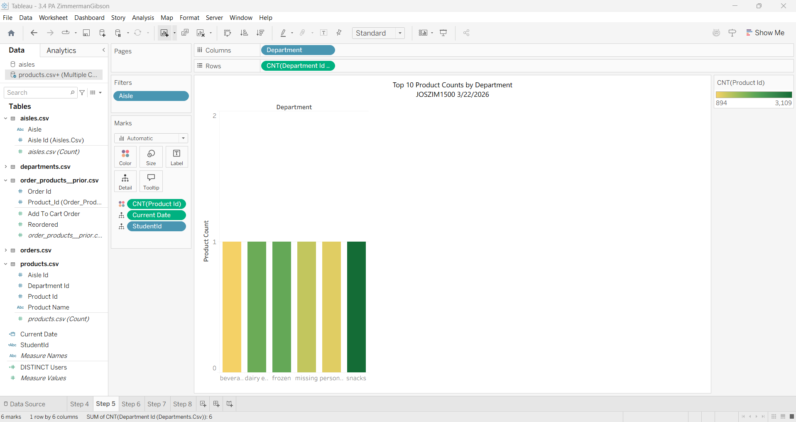
- Update the Dual Axis Chart. Remove the average days since prior order from the Rows shelf and replace it with the sum of add to cart orders.
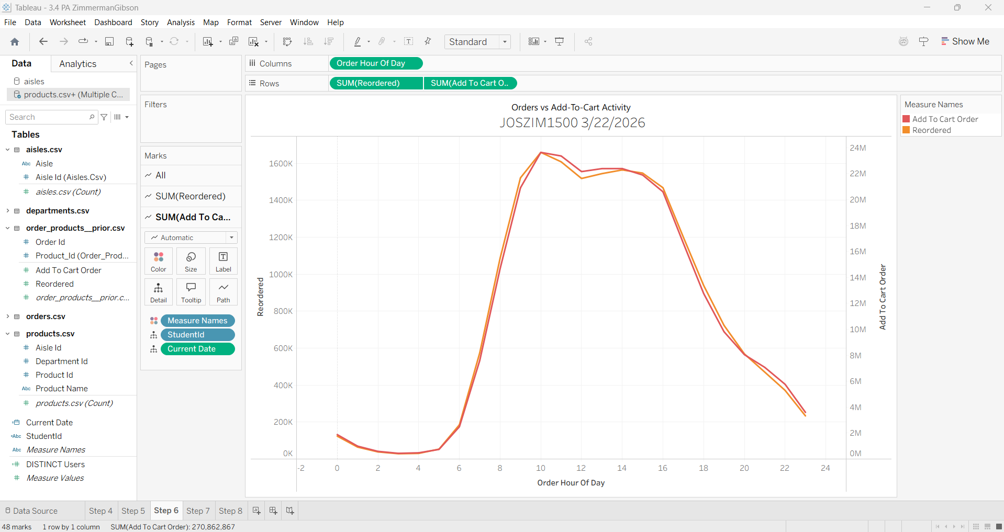
- Create a Tree Map displaying the product name as a label and the count of order_products_prior for both size and color. Add a filter for the top ten aisles by order_products_prior count.
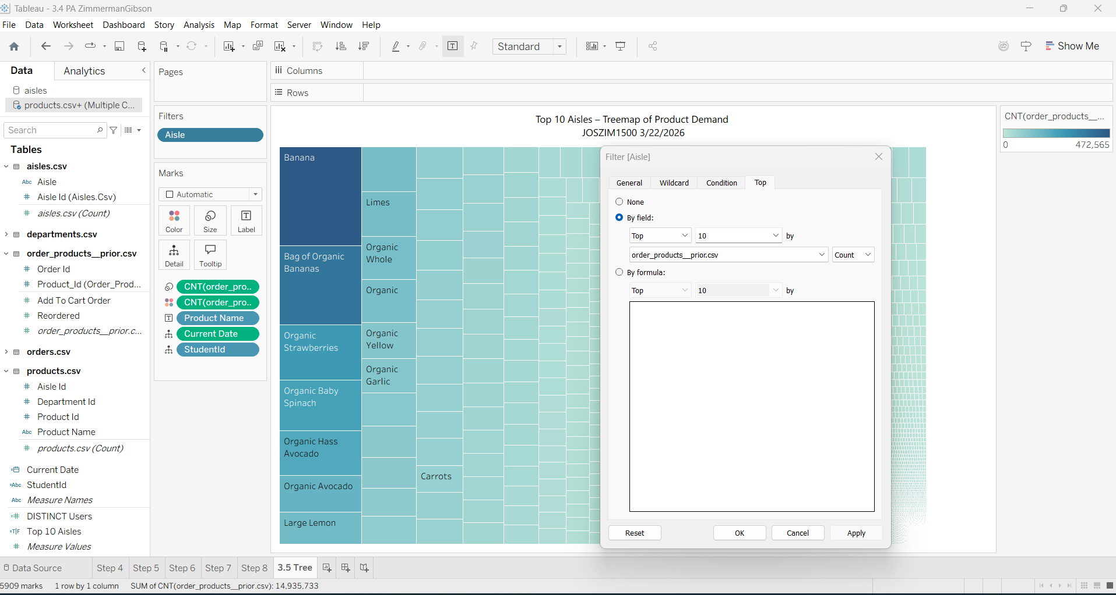
Not filtering correctly
- Create a Scatter Plot of the count of orders over the average days since prior order. Include the product id and name in the detail mark.
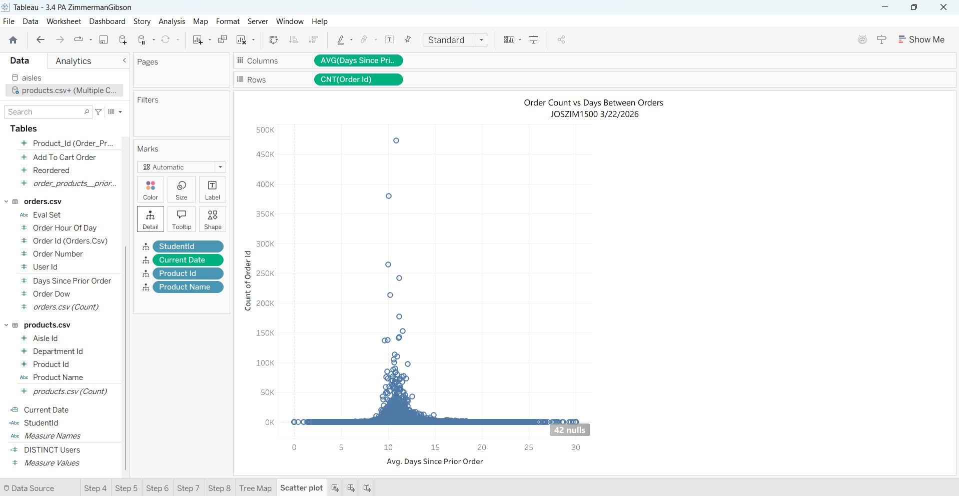
- Create a story with the above visualizations. Include a paragraph caption for each visualization that gives a name to the graph and details the key insights gathered from it.
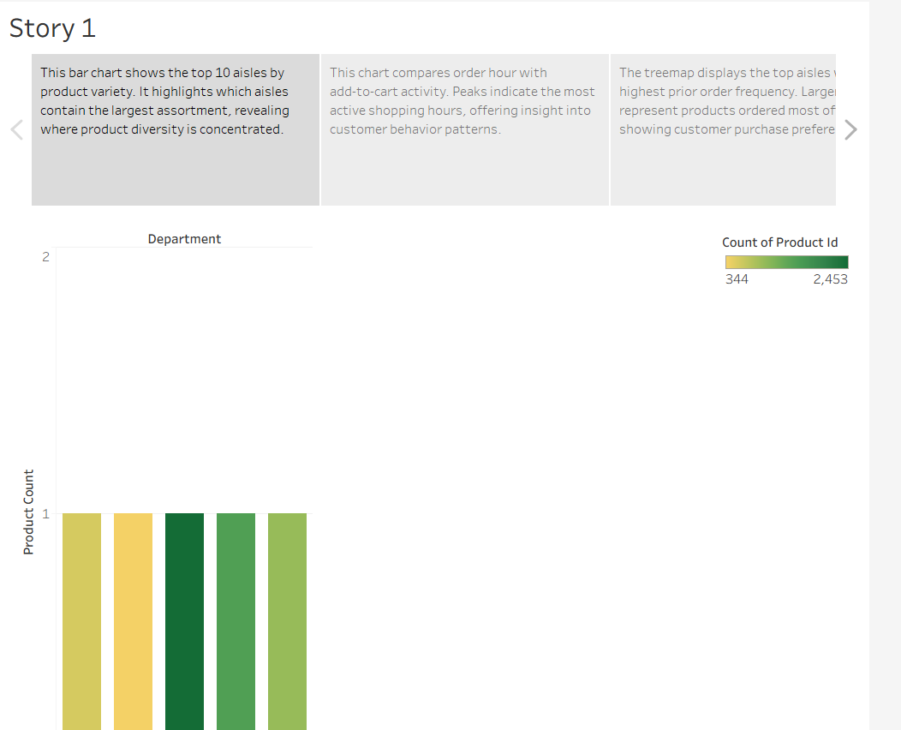
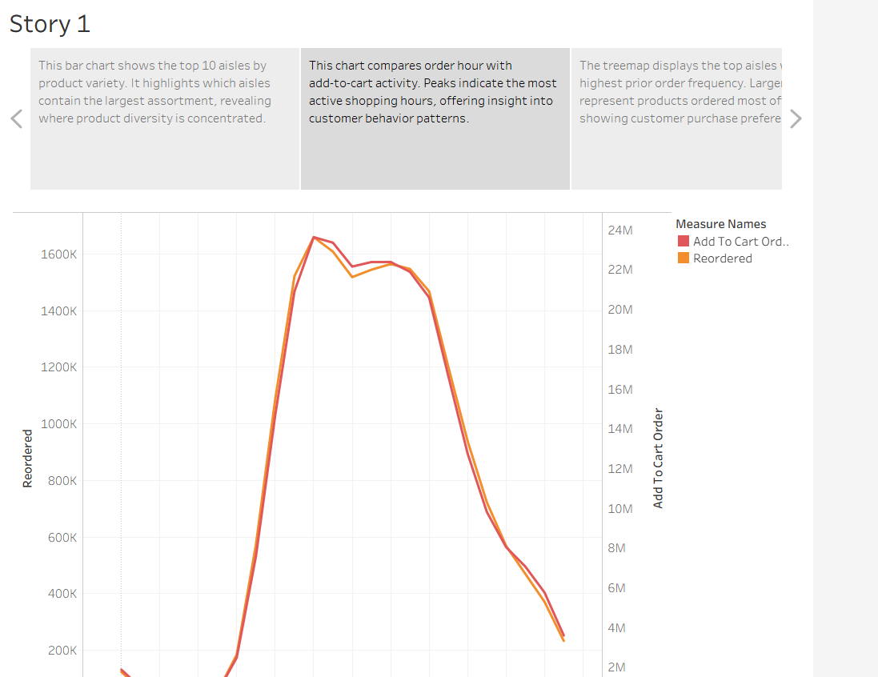
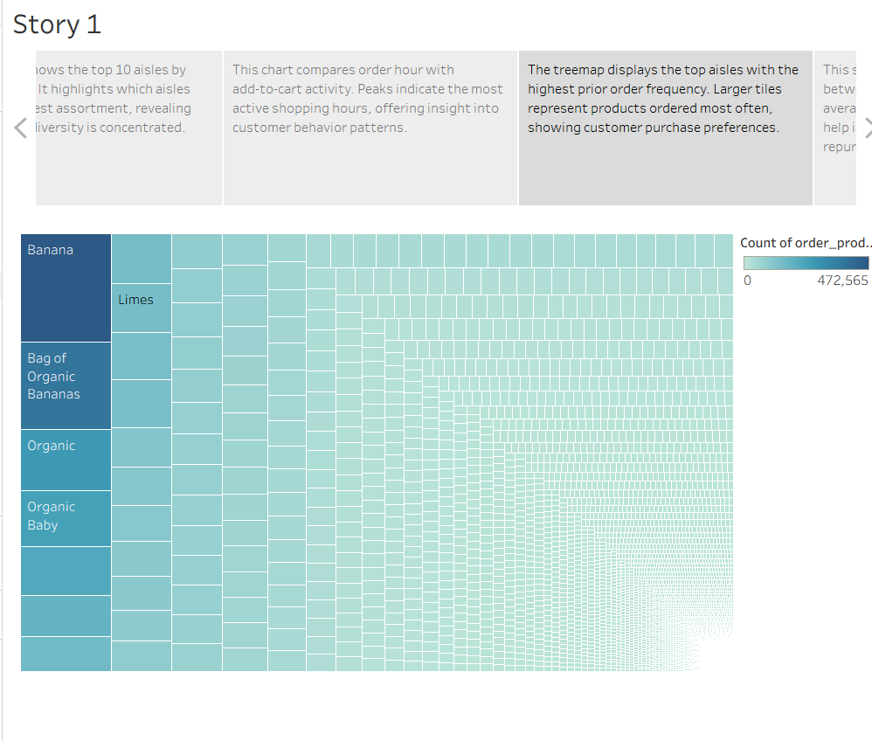
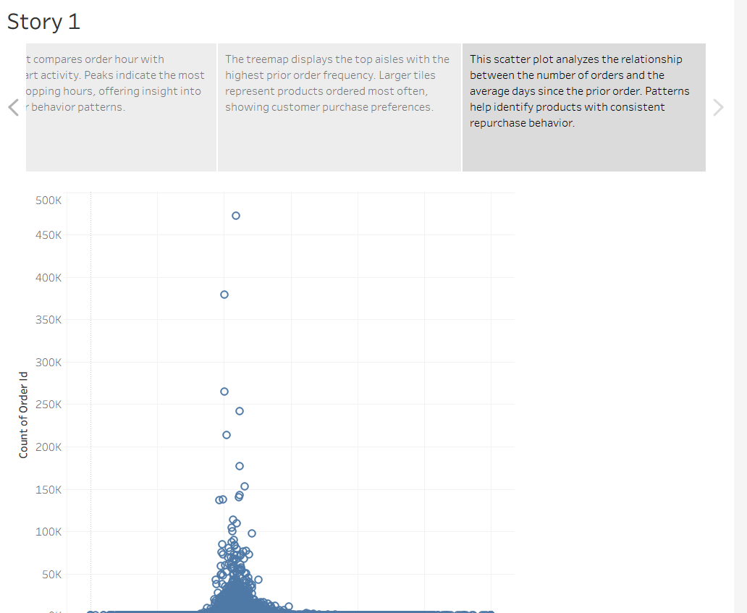

Questions
- What are some accessibility concerns for the Tree Map? How does the use of the marks help mitigate those issues?
Tree maps can be hard to read because the boxes can become very small, making labels difficult to see. Colors alone can also be challenging for people with color-vision limitations, and similar colors may cause confusion.
Using marks, such as labels, size differences, and clear color contrast, helps reduce these issues. Labels make each section easier to identify, size differences highlight which items are larger or smaller, and distinct color choices help viewers better separate categories even when the shapes are small.

- What other combinations of data from this dataset would provide useful insights as a Dual-Axis Chart? What insights might they highlight?

A Dual-Axis Chart is useful when comparing two related measures at the same time. In this dataset, several combinations could highlight meaningful insights:
- Count of orders vs. average days between orders
This pairing could show whether products ordered more frequently also have shorter reorder times.
- Count of products added to cart vs. total orders
This could help reveal whether high add-to-cart activity matches actual purchasing behavior.
- Aisle popularity vs. total unique products in that aisle
This could highlight aisles that attract many orders even if they offer fewer products, or aisles with many product options that don’t generate as many orders.
These types of comparisons make patterns easier to spot because both measures appear on a single combined view.

- What are some best practices regarding storyboard flow when presenting these visualizations?

A storyboard should guide the viewer smoothly through the visuals, so the overall message is easy to understand. Strong flow typically includes:
- Starting with broad information – Begin with general trends so the audience has context.
- Moving toward more detailed visuals – Follow with charts that focus on specific categories, products, or patterns.
- Using consistent colors and layout – Uniform design helps viewers connect related information.
- Adding clear captions – Each slide should briefly explain what the visualization shows and why it matters.
- Ending with key insights – The final slide should summarize the main takeaways from the visuals.
This structure helps the audience absorb information step-by-step and understand the story behind the data.

